1. Download installation resources (comes in zip package).

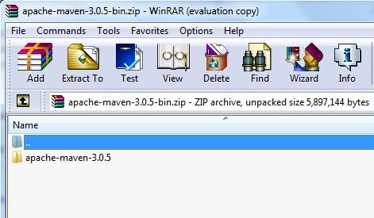

2. Extract the whole folder into local Apache Software directory as shown below if directory does not exist, create manually.

